Networks / PCA / connectedness: AUDUSD and USDJPY
Method 28 / pair slice of eight-major system / Alpari D1 full available history

Study setup
Logical pair: AUDUSD , USDJPY
Broker symbols: AUDUSD_i , USDJPY_i
Snapshot: 2026-11-03_majors_alpari_D1
Timeframe: D1
Matched return window: 1999-01-05 to 2026-11-02 (UTC bar dates)
Matched return count n: 7199
System panel n: 7127
Dropped unfinished last bar dated 2026-11-03 UTC after a tick-volume check against the prior complete day.
VAR lag (BIC): 1; GFEVD horizon H=10
System TCI: 54.0425
Complete matched rows (Excel): AUDUSD-USDJPY_Network_D1.xlsx

Method carried forward
Three system-level tools on the eight-major daily log-return panel. (1) Network distance d_ij = sqrt(2*(1-rho_ij)) from Pearson correlation. (2) PCA eigenvalues of the correlation matrix R (R v = lambda v). (3) Diebold-Yilmaz total connectedness index (TCI) from a VAR with generalised forecast-error variance decomposition (GFEVD), horizon H=10; lag order chosen by BIC with maxlags=10. TCI = 100 * sum_{i!=j} theta_tilde_ij / N after row-normalising GFEVD shares. Pair reports show d_ij, rho_ij, and the directed pair spillover shares from the system theta_tilde matrix. Edges and TCI are not trading signals.

Pair results
Pearson rho: -0.086373
Network distance d_ij: 1.474023
theta_tilde[AUDUSD->USDJPY] (row AUDUSD, col USDJPY): 0.002879
theta_tilde[USDJPY->AUDUSD] (row USDJPY, col AUDUSD): 0.007224
PCA lambda_1: 3.817794
PCA variance share PC1: 0.477224

Conclusion
For AUDUSD-USDJPY: d_ij=1.4740 from rho=-0.0864. Pair spillover shares 0.0029 / 0.0072. System TCI=54.04. Not a trading signal.

Pair charts
Daily closes

Daily log returns
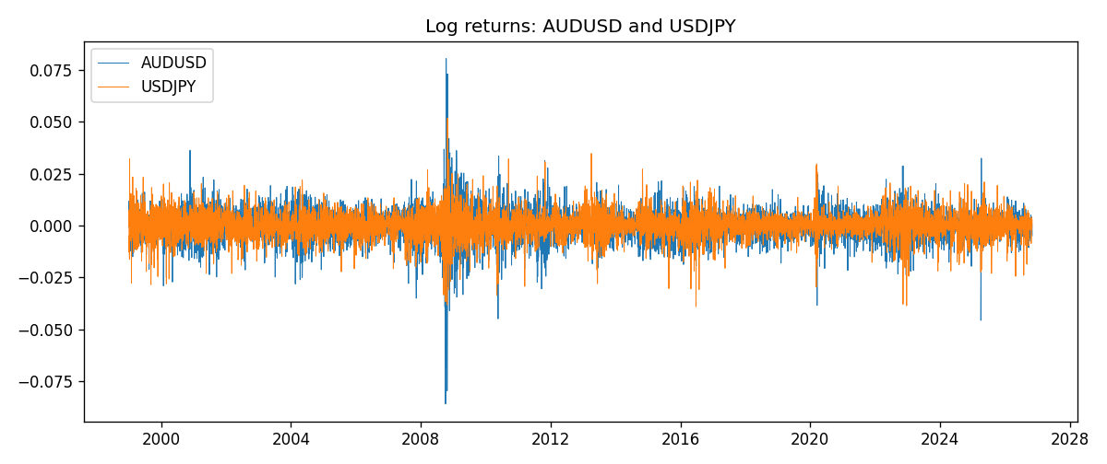

System charts (shared)
Correlation matrix

Distance matrix

PCA eigenvalues

GFEVD theta_tilde


Data report
First 15 matched rows
time | AUDUSD_log_return | USDJPY_log_return
1999-01-05 | -0.00080418179 | -0.00017868311
1999-01-06 | 0.011836351 | 0.0075660159
1999-01-07 | 0.0088650256 | -0.012851583
1999-01-08 | 0.00031515916 | -0.0047719894
1999-01-11 | 0.0072213815 | -0.016195423
1999-01-12 | -0.0048608485 | 0.032310364
1999-01-13 | -0.0078902098 | 0.0081373171
1999-01-14 | -0.002696916 | 0
1999-01-15 | 0.007123101 | 0.0055343401
1999-01-18 | 0.00094592471 | 8.7600193e-05
1999-01-19 | 0.0072225153 | -0.0056219403
1999-01-20 | 0.0012507819 | -0.0053879917
1999-01-21 | 0.00078094498 | 0.0084664056
1999-01-22 | -0.012252745 | 0.0060412564
1999-01-25 | -0.0039591468 | -0.0073594164
Last 15 matched rows
time | AUDUSD_log_return | USDJPY_log_return
2026-10-13 | 0.0035007712 | -0.0018932826
2026-10-14 | -0.0015193215 | 7.5800166e-05
2026-10-15 | -0.0075447063 | -0.0018524319
2026-10-16 | 0.0033906408 | -0.00037976126
2026-10-19 | 0.0050859986 | 0.0034946841
2026-10-20 | 0.0034620426 | -0.0022546642
2026-10-21 | 0.0036066384 | -0.00032883504
2026-10-22 | -0.0012672558 | -0.0085942669
2026-10-23 | 0.0023765656 | 0.00035080446
2026-10-26 | -0.0032032829 | 0.0041238746
2026-10-27 | 0.0016669876 | 0.0027651658
2026-10-28 | 0.0040915541 | -0.00095679538
2026-10-29 | -0.0040915541 | -0.00038043789
2026-10-30 | 0.0010102376 | -0.0010596481
2026-11-02 | -0.0049184984 | 0.0026438521

